**NITTE MEENAKSHI INSTITUTE OF TECHNOLOGY**

(AN AUTONOMOUS INSTITUTION, AFFILIATED TO VISVESVARAYA TECHNOLOGICAL UNIVERSITY, BELGAUM, APPROVED BY AICTE & GOVT.OF KARNATAKA



Application Development using JAVA

(18CS45)

*Submitted in partial fulfilment of the requirement for the award of Degree of*

*Bachelor of Engineering*

*in*

*Computer Science and Engineering*

Submitted by:

|  |  |
| --- | --- |
| DARSHAN R | USN: 1NT20CS052 |
| SAMIR MULMI | USN: 1NT20CS153 |



**Department of Computer Science and Engineering**

2021-22

|  |  |  |
| --- | --- | --- |
|  | **Nitte Meenakshi Institute of Technology**  (AN AUTONOMOUS INSTITUTION AFFILIATED TO VISVESVARAYA TECHNOLOGICAL UNIVERSITY, BELGAUM)  PB No. 6429, Yelahanka, Bangalore 560-064, Karnataka  Telephone: 080- 22167800, 22167860  Fax: 080 - 22167805 |  |

**Department of Computer Science and Engineering**

CERTIFICATE

This is to certify that the Course Project titled “Second Handlers” is an authentic work carried out by DARSHAN R (1NT20CS052), SAMIR MULMI (1NT20CS153) Bonafede students of Nitte Meenakshi Institute of Technology, Bangalore in partial fulfilment for the award of the degree of *Bachelor of Engineering* in COMPUTER SCIENCE AND ENGINEERING of Visvesvaraya Technological University, Belagavi during the academic year *2021-2022.*

|  |  |  |
| --- | --- | --- |
| **Internal Guide** |  | **Signature of the HOD** |
|  |  |  |
| Mrs.Shobha P  Assistant Professor, Dept. CSE, NMIT Bangalore |  | Dr.Sarojadevi H.  Professor, Head, Dept. CSE, NMIT Bangalore |

**DECLARATION**

We hereby declare that

(i) This Presentation does not contain text, graphics or tables copied and pasted from the Internet, unless specifically acknowledged, and the source being detailed in the report and in the References sections.

(ii) All corrections and suggestions indicated during the internal presentation have been incorporated in the report.

(iii) Content of the report has been checked for the plagiarism requirement

Name : DARSHAN R USN : 1NT20CS052 Signature : 

Name : SAMIR MULMI USN : 1NT20CS153 Signature : 

|  |  |  |
| --- | --- | --- |
|  |  |  |
|  |  |  |
|  |  |  |
|  |  |  |

Date: 27 July 2022

**ACKNOWLEDGEMENT**

The satisfaction and euphoria that accompany the successful completion of any task would be incomplete without the mention of the people who made it possible, whose constant guidance and encouragement crowned our effort with success. we express our sincere gratitude to our Principal **Dr. H. C. Nagaraj**, Nitte Meenakshi Institute of Technology for providing facilities.

We wish to thank our HoD**, Dr. Sarojadevi H** for the excellent environment created to further educational growth in our college. We also thank him for the invaluable guidance provided which has helped in the creation of a better technical report.

Thanks to our Subject Faculty **Ms Shobha P** for guiding and helping us out in the successful completion of this presentation.

|  |  |  |
| --- | --- | --- |
| Name  DARSHAN R  SAMIR MULMI | USN  1NT20CS052  1NT20CS153 | Signature |

**ABSTRACT**

In our day to day lives, we come across many things that were dear to us once but are not anymore.

These could be the books we’ve already read, the clothes we no longer need, crockery items, mobile phones and many more such things.

But these things, no longer useful to us can be useful to others.

So, to connect such people, together we have established a platform “Second Handers”.

We at Second Handers provide a digital platform through which people can rid of the products not in use by posting a picture and some details of that product on our platform.

The person interested in buying the product can make an offer to the owner. The deal is made and the product is sold only if both the parties agree on the decided price. Hence, satisfying both the buyer and the seller.

The feature of reward points which we have introduced is what will attract the people more to our platform.

**Table of Contents**

**Chapter 1:** **Partwise explanation**

**Chapter 2:** **Concepts used**

**Chapter 3:** **Summary and Future work**

**Chapter 4:** **Screenshots of working model**

**Chapter 5: Conclusion**

**Bibliography**

1. **Partwise explanation of application**

This Second Handers is a simple solution for joining the seller and the buyer in the world with a secure line so the transaction can go peacefully without the intervention of any third party or any other medium. We provide them with a reliable secure and easy to use software to work with. We have used MySQL database to store and retrieve data at fingertips. Made various tables and triggers to automate the system.

**The Features:**

1. Register
2. Login
3. See the post with and without login
4. Post an item by authenticated user
5. Request/offer to purchase an item by authenticated user
6. Accept/deny the request/offer by the seller
7. Update profile
8. Get Rewards by selling your products

**Storing and Retrieving data**

As stated earlier we have used MySQL database to store and retrieve information fast.

The tables in that database are

1. User
2. Item
3. Category
4. Requests
5. Rewards

There are some triggers also that we created to automate some process like incrementing the total posts of user or incrementing the total posts of a category

**Chapter 2: Concepts Used**

### JavaFX

JavaFX is a Java library using which you can develop Rich Internet Applications. By using Java technology, these applications have a browser penetration rate of 76%.

Following are some of the important features of JavaFX −

* **Written in Java** − The JavaFX library is written in Java and is available for the languages that can be executed on a JVM, which include − **Java, Groovy and JRuby**. These JavaFX applications are also platform independent.
* **Built-in UI controls** − JavaFX library caters UI controls using which we can develop a full-featured application.
* **CSS like Styling** − JavaFX provides a CSS like styling. By using this, you can improve the design of your application with a simple knowledge of CSS.
* **Integrated Graphics library** − JavaFX provides classes for **2d** and **3d** graphics.

##### **Event Handling in Java:**

Event handling is prime to Java programming because it’s integral to the creation of applets and other sorts of GUI-based programs.

## Connecting to MySQL Using the JDBC DriverManager Interface

When you are using JDBC outside of an application server, the DriverManager class manages the establishment of connections. Specify to the DriverManager which JDBC drivers to try to make Connections with. The easiest way to do this is to use Class.forName() on the class that implements the java.sql.Driver interface. With MySQL Connector/J, the name of this class is com.mysql.jdbc.Driver. With this method, you could use an external configuration file to supply the driver class name and driver parameters to use when connecting to a database.

That is connected to a particular database by calling **DriverManager.getConnection():**

Once a connection is established, it can be used to create Statement and PreparedStatement Objects, as well as retrieve metadata about the database.

## 2.1  Using JDBC Statement Objects to Execute SQL

Statement objects allow you to execute basic SQL queries and retrieve the results through the ResultSet class, which is described later.

To create a Statement instance, you call the createStatement() method on the Connection object you have retrieved using one of the DriverManager.getConnection() or DataSource.getConnection() methods described earlier.

Once you have a Statement instance, you can execute a [SELECT](https://dev.mysql.com/doc/refman/5.7/en/select.html) query by calling the executeQuery(String) method with the SQL you want to use.

**ResultSet:** A ResultSet object maintains a cursor pointing to its current row of data. Initially the cursor is positioned before the first row. The next method moves the cursor to the next row, and because it returns false when there are no more rows in the ResultSet object, it can be used in a while loop to iterate through the result set.

**Chapter3: Summary and future work**

So we have implemented this whole software by following the above concepts.

Our future aim is to integrate this app with a more reliable database such as NoSQL for better management. We also plan on integrating a chatbot for the ease of users wherein their queries would be resolved. Surely we plan on making the graphical user interface better and thus enhancing our user experience.

Integrating the app with payment gateways, with third party apps such as WhatsApp, introducing memberships and providing certain benefits to our members are also on the list.

**Chapter 4: Screenshots of the Application**

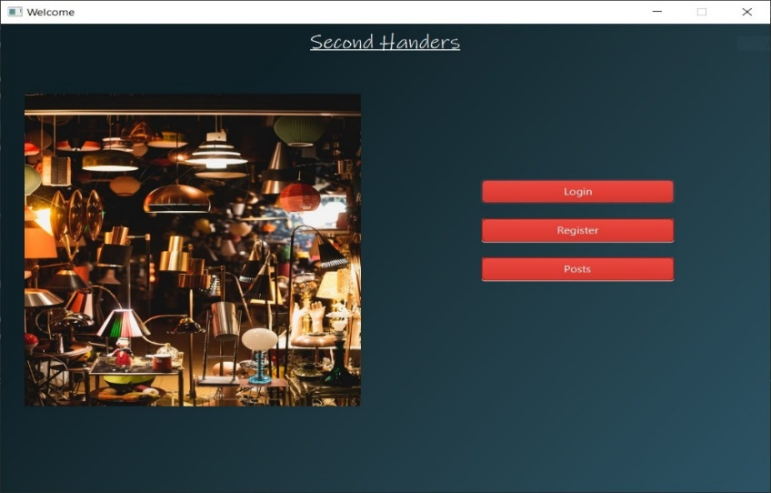

4.1 main page

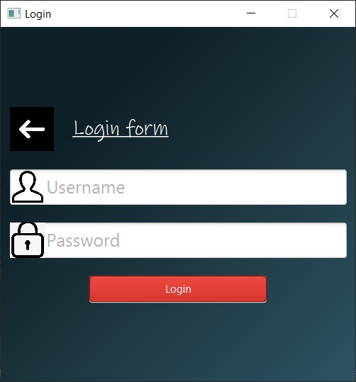

4.2 login page where we need to enter the user crendtials

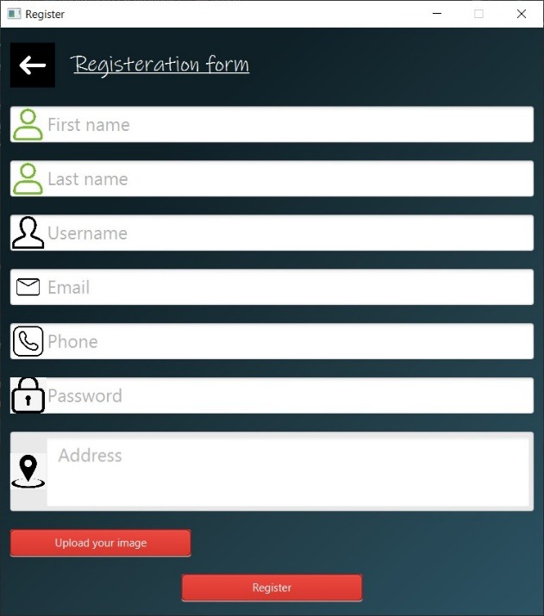

4.3 this page is used to get registered into second hadlers, you should fill the form to get registered into second handlers

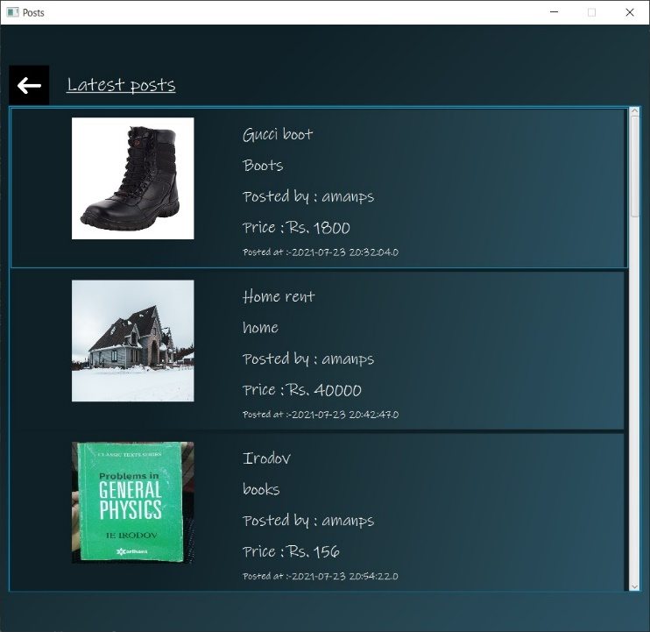

4.4 this page shows you all the lastest files uploaded by the other users

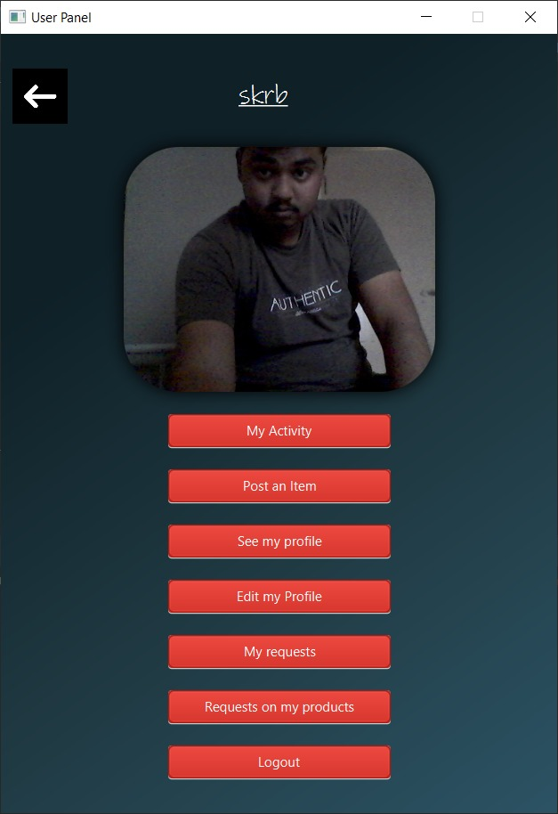

4.5 this page shows u all features provided by the second handlers

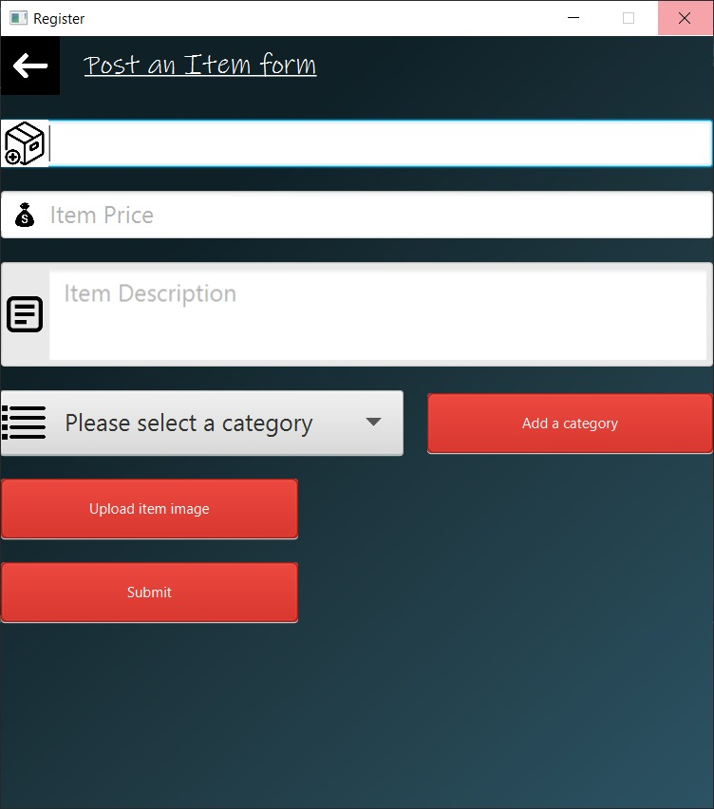

4.6 In thia page we can post the item to be sold

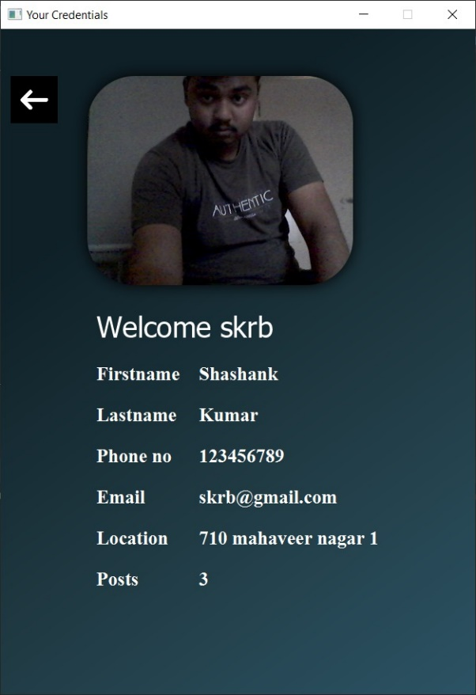

4.7 displays user details

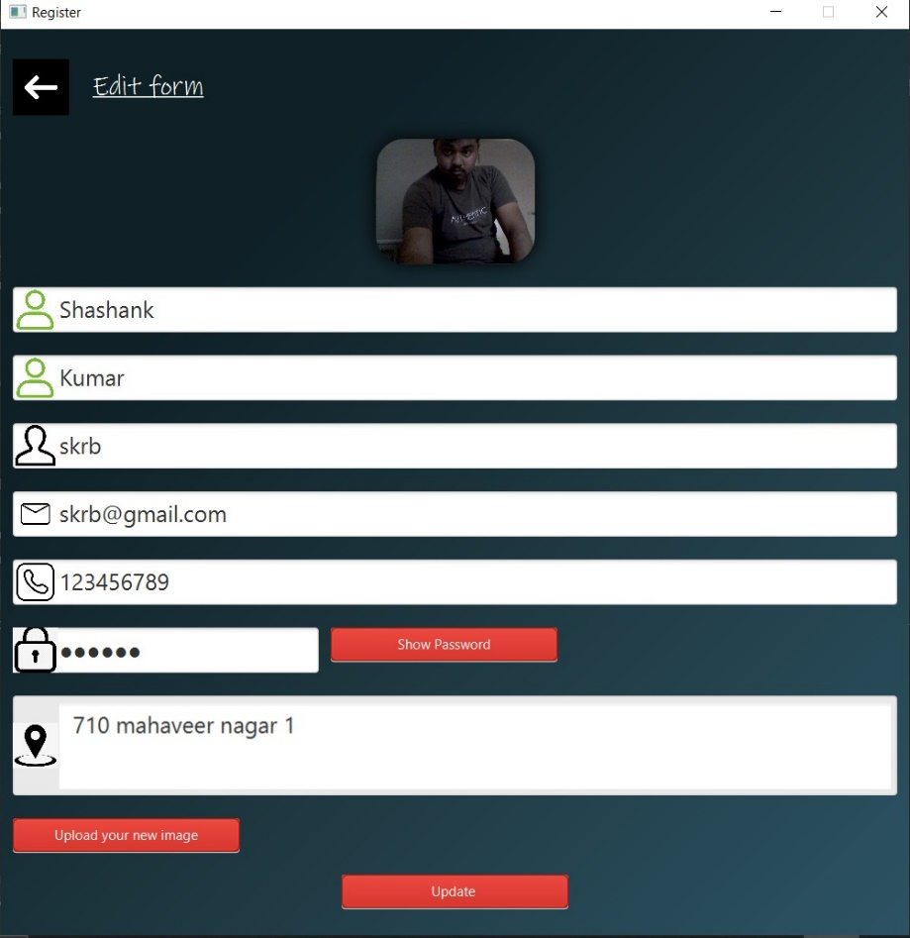

4.8 you can edit your details in this page

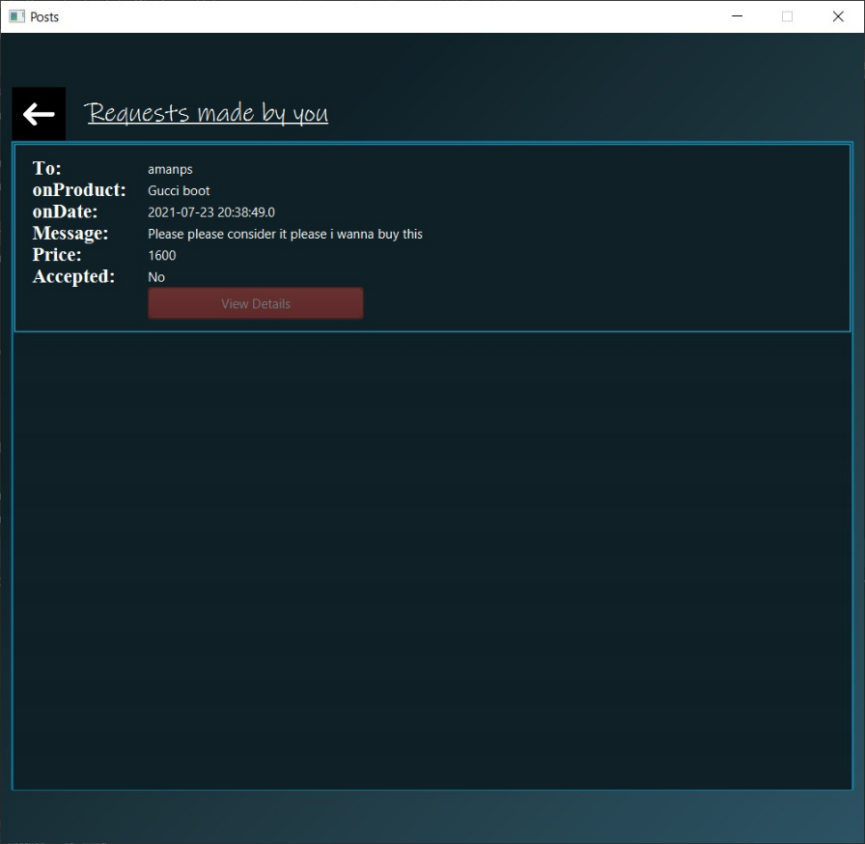

4.9 This page shows you requests made by you to purchase the items

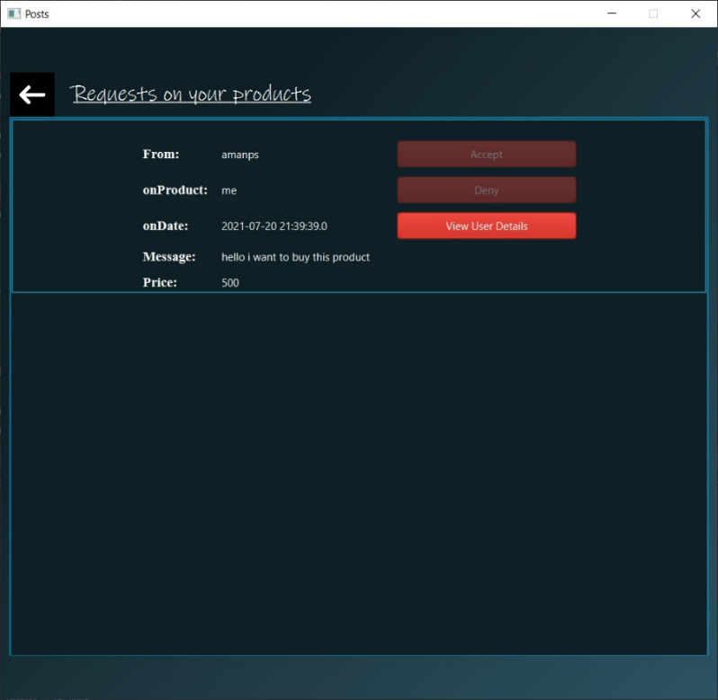

4.10 this page display the user who is interested to buy your product

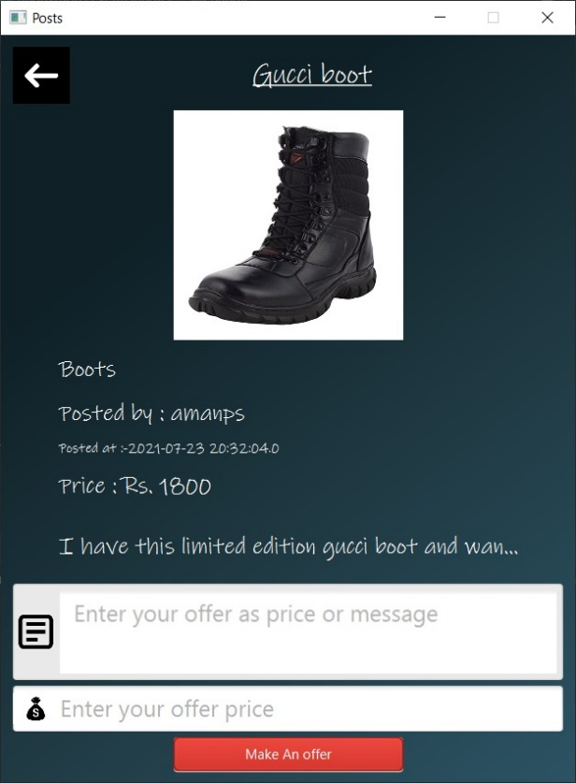

4.11 In this you can make a offer to buy a item

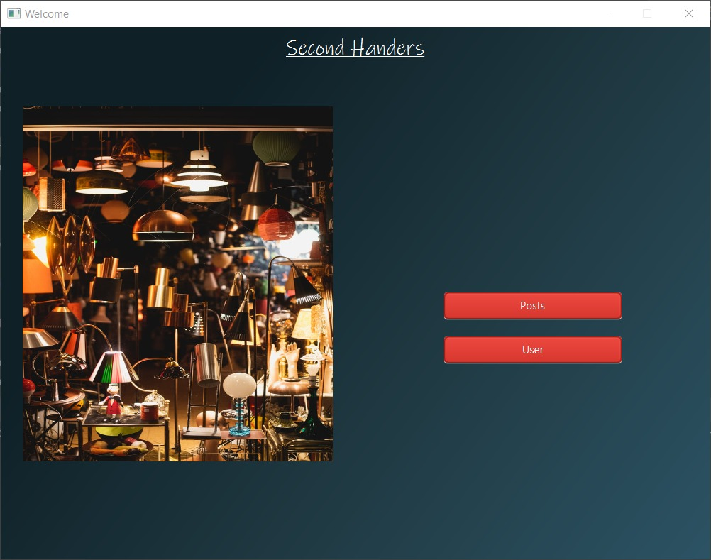

4.12 this page u can click posts to see other user posts and user to see your details

**Chapter5: Conclusion**

Overal this java froject was a very interesting one we learnt about a lot of things by doing this project, it helped us to learn more about JAVAFX and know about its usage and working. This project also helped us in improving our skills and knowledge in Eclipse IDE,, so that we can further gain more knowledge about programing in such IDE’s. It also helped to improve our skills in developing user interfaces.

JavaFx is a basic UI designing system, since we are knowing it wery well , it will surely improve our UI developing skills in future endavours

This was a project in which we improved our knowledge and skill in programing language and front end designing languages, hence this was a very important project in our engineering cource.

**Bibliography**

[1]. Java: The Complete Reference

Book by Herbert Schildt

[2]. Thinking in Java

Book by Bruce Eckel

[3]. Mastering JavaFX 10: Build Advanced and Visually Stunning Java Applications

Book by Sergey Grinev

[4] Java notes

by Mrs Shoba P mam

**Nitte Meenakshi Institute of Technology(NMIT) Bangalore**

|  |  |  |
| --- | --- | --- |
| **Projects Report.** | | |
| **1.Department: Computer Science and Engineering** | | |
| **2.Year: 2021-2022** | | **3.Semester: 4** |
| **4. Student Name** | | **Darshan R , Samir Mulmi** |
| **5. USN** | | **1NT20CS052, 1NT20CS153** |
| **6. Name of the Project Guide** | | **Mrs Shobha P** |
| **7. Domain** | | **JAVA** |
| **8. Title/Topic of the Project** | | **Second Handlers** |
| **9. Abstract (Not more than 100-150words)** | | |
| In our day to day lives, we come across many things that were dear to us once but are not anymore.  These could be the books we’ve already read, the clothes we no longer need mobile phones and many more such things. But these things, no longer useful to us can be useful to others.  So, to connect such people, together we have established a platform “Second Handers”.  A digital platform through which people can get rid of the products not in use by posting a picture and some details of that product on our platform.  The deal is made and the product is sold only if both the parties agree on the decided price.  Hence, satisfying both the buyer and the seller.. | | |
| **10. Objectives** | **To learn more about JAVA, JAVAFX, JDBC, and UI designing** | |
| **11. Deliverables** |  | |
| **12. Status of the Project (Kindly provide correct status of the project)** | | |
| **a. Publication Status : Not published b. Productized : No c. Patent Filed : No**  **d. Plagiarism Check : e. Best project status Describe :** | | |
| **Signature of the Student** | | |
| **Signature of the Guide** | | |
| **Signature of the Head** | | |